1. Ice breaker:
2. Connor Troy Hayes

Favorite ice cream: Cookies & Cream

Something I'd like to do before September: Go on a trip

1. Luvneet Singh Bamrah

Favorite ice cream: Chocolate

Something I'd like to do before September be able to click 50cps

1. Java and C

**Java**

1. The source code:

public class Helloworld{  
 public static void main(String[] args) {  
 System.out.println("Helloworld");  
 }  
}

1. Directory listing

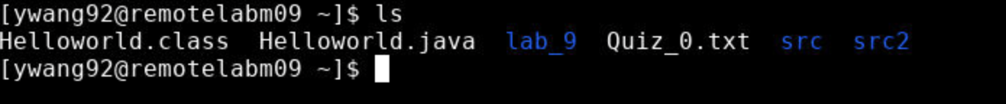

1. Screen shot of outcome:



**C**

1. Source code:

#include <stdio.h>

int main(int argc, char * * argv){

printf("Hello World\n");

return 0;

}

1. Directory listing



1. Output



**Explanation**

When compiling the java file, the java compiler generated a .class file but the C compiler generated a .o file and an excitable file without suffix.

According to the lecture: “Linker: combine object code with other code

(e.g. libraries) needed to produce executable program.”So C compiling will generate a executable program. But java compiler generates an intermediate language and then translated to machine language when running the java program using java command. But C compiler generate a native machine language file so the machine can run it directly.

1. Repeated Digits
2. Source code:

#include <stdio.h>

int main(int argc, char * * argv){

int value;

int iErr;

int count = 0;

printf("Value to examine: ");

iErr = scanf("%d",&value);

if(iErr != 1){

printf("Unable to read the value\n");

return 0;

}else{

while(value > 0){

if(value%2 == 1){

count++;

}

value = value/2;

}

printf("Number of ones: %d \n",count);

return 1;

}

}

1. Directory lising:



1. Testing

文本

